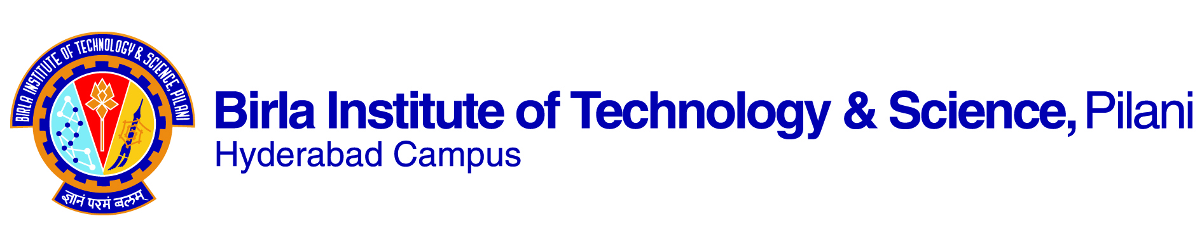

**SECOND SEMESTER 2022-2023**

# Course Handout Part II

**Date: 16.01.2023**

In addition to part-I (General Handout for all courses appended to the time table) this portion gives further specific details regarding the course.

*Course No.* : **CS F303**

## Course Title : **Computer Networks**

Instructor in Charge : Dr.Pragati Shrivastava (pragati.shrivastava@hyderabad.bits-pilani.ac.in)

## Instructors : Dr. Dipanjan Chakraborty, Dr. Rajib R. Maiti,

**Scope and Objectives of the Course:**

* This course will give you a breakdown of the applications, communications protocols, and network services that make a computer network work.
* We will follow a bottom-up approach to computer networking, which will enable you to learn the basics and then built upon them. This will also enable us to understand each layer independent of the layer above and the services that a layer provides to its next upper layer.
* Most of the time our example network will be the Internet.
* Real-life examples with suitable demonstration through various tools (such as cisco packet tracer) will be provided in order to understand how network and internetwork operates.

**Textbooks:**

[T1] James F. Kurose and Ross, Computer networking: a top-down approach featuring the Internet, 7th Ed., Pearson, 2017.

**Reference books**

1. [R1] Behrouz A. Forouzan. Data Communications and Networking. McGraw Hill Pub., 5th edition, 2013.
2. [R2] Andrew S. Tanenbaum. Computer Networks. Fourth Edition, Pearson Education, 2006.
3. [R3] L. Peterson and B. Davie. Computer Networks: A Systems Approach. Fourth Edition, MK, 2007.
4. [R4] W. Richard Stevens, “TCP/IP Illustrated Volume 1, The protocol”, 2nd Ed. Addison-Wesley,2011.

**Course Plan:**

|  |  |  |  |  |
| --- | --- | --- | --- | --- |
| Sl. No. | Learning Objectives | Topic | Chapters | Lectures |
| 1. | To understand the need, evolution, current status of computer networks.  To understand the types of computer networks | Introduction to computer networks, history of internet, standards. | T1 (Ch. 1) | 2 |
| 2. | To understand the network layered architecture, models and development standards. | Protocol layering. | T1 (Ch. 1) | 2 |
| 3. | To understand the performance evaluation of switched networks. | Delay and Loss in Switched Networks. | T1(Ch.1) | 2 |
| 4 | To understand Application layer and HTTP. | Application Layer: Hypertext Transfer Protocol, HTTP Message Format, Cookies, Conditional GET. | T1 (Ch. 2) | 2 |
| 5 | To understand DNS | DNS and Name system, DNS Working, DNS Caching and Performance. | T1 (ch2) | 2 |
| 7. | To understand socket Programming,  client/server architecture | Introduction to sockets , UDP/TCP sockets | T1 (Ch. 2), R1 (Ch. 25) | 2 |
| 8. | To learn basics of transport layer and reliable data  transfer protocols | Go-Back-N and Selective Repeat protocols | T1: (Ch.3) | 3 |
| 9. | To understand the flow control protocol at the transport layer. | Transport Layer: Multiplexing, Demultiplexing, UDP, Principles of Reliable Data Transfer (Go-Back-N, and Selective Repeat). | T1 (Ch. 3) | 3 |
| 10. | To understand the error mitigation at the transport layer. | TCP Error Control and Congestion Control. | T1 (Ch. 3) | 3 |
| 11. | To understand how to estimate the congestion characteristics. | TCP: Segment structure, RTT Estimation and Timeout, TCP Flow Control. | T1 (Ch. 3) | 3 |
| 12 | To understand internet connection models.  To understand how devices are identified in the internet. | Network Layer: Virtual Circuits and Datagram Networks, what is Inside a Router? Forwarding and Addressing in the Internet. | T1 (Ch. 4) | 4 |
| 13. | To understand how packets are routed in the internet. | Routing Algorithms: Shortest Path, Flooding, Link State, Distance Vector, and Hierarchical Routing. | T1 (Ch. 5) | 4 |
| 14. | To understand various routing protocols | Routing Protocols: OSPF, RIP, BGP, routing policy | T1 (Ch. 5) | 3 |
| 15. | To understand basics of link layer. | Link-Layer Addressing and ARP | T1 (Ch. 6) | 3 |
| 16 | To understand the error control protocols. | Data Link Layer: Services, Error Detection and Correction Techniques (Parity Checks, Checksums, CRC). | T1 (Ch. 6) | 2 |
| 17. | To understand the local wireless network standard. | Wireless Networks: Wi-Fi: 802.11 Wireless LAN Architecture and Protocol | T1 (Ch. 7) | 3 |

**Evaluation Scheme:**

|  |  |  |  |  |
| --- | --- | --- | --- | --- |
| **Component** | **Duration** | **Weightage (%)** | **Date & Time** | **Nature of Component** |
| Comprehensive examination | 180 min | 40% | 11/05 AN | Closed book |
| Mid-term examination | 90 min | 30% | 14/03  4.00 - 5.30PM | Closed book |
| QUIZ  (1 Nos.) | 30 min | 10% | TBA | Open book |
| Lab Test (2 Nos.) | 60 min | 20% | 4/03 AN  29/04 AN | Open book |

For Comprehensive exam and Mid-semester Test, the mode (offline) and the duration are subject to changes as decided by the AUGSD/Timetable division in future.

**Details:**

One lab-test will be conducted before the mid-sem; remaining after the mid-sem.

**Chamber Consultation Hour:** TBA

**Notices:** To be displayed on Google classroom only.

**Make-up Policy:**

Make up will be allowed only in extreme situations and institute rules will apply. However, *prior permission* from the IC is compulsory.

**Academic Honesty and Integrity Policy:**

Academic honesty and integrity are to be maintained by all the students throughout the semester and no type of academic dishonesty is acceptable.

**INSTRUCTOR-IN-CHARGE**

**CS F303**